**Instructions for using the**

**Eta Phi Beta Sorority, Incorporated**

**Online Photo Directory**

1. While on the Members Only page, **Click** the following link <http://etaphibeta.online-photo-directory.com/>
2. You will see the following page

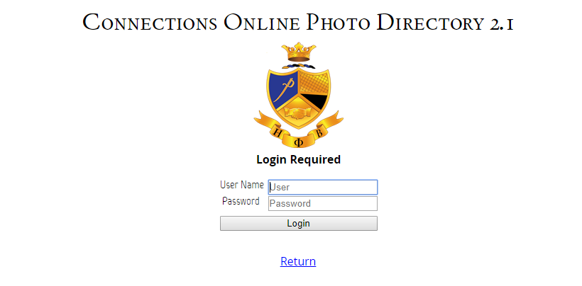

*Note this information will appear at the bottom of each page; however, it does not relate to the sorority directory. 

1. **Type** the following information
   1. User Name **etaphibeta**
   2. Password **redandgold**
2. Click the **Login** button and the following page will appear

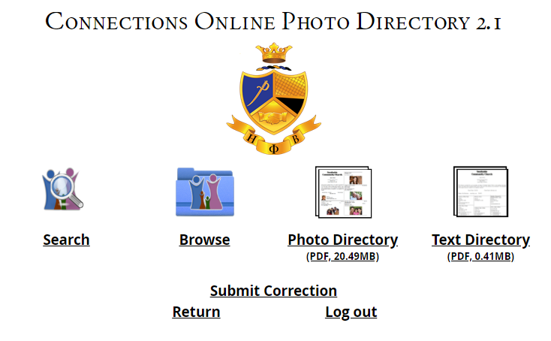

1. Explanation of Icons
   1. **Search** – Allows you to enter data and search by different criteria

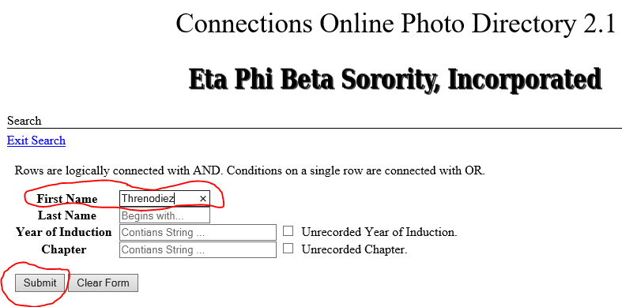

* + 1. Once the criteria is entered you can **SUBMIT** or **CLEAR FORM**. If a criteria is met, something similar to the picture below will appear.

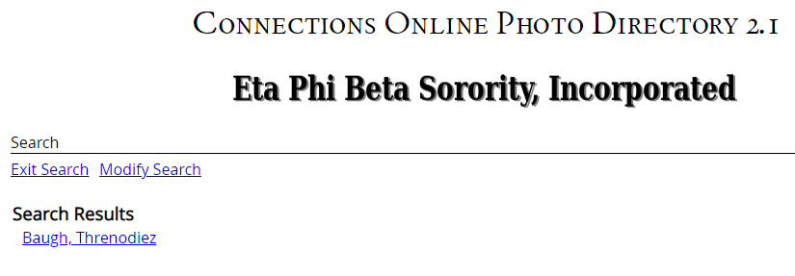

* + 1. Once the results are displayed, **Click** on your choice and a screen similar to what is displayed below will appear based on who is chosen

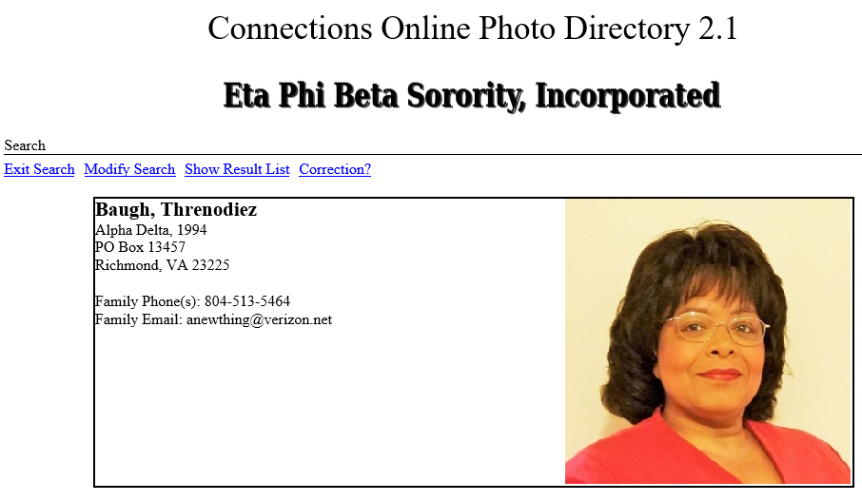

* + - 1. **Exit Search** – this will take you back to the home page
      2. **Modify Search** – this will take you back to the Search Page and allow you to change the search criteria
      3. **Show Result List** – Depending on your criteria, there may be more than one result. Should that be the case, a list of the results will be displayed. Clicking on **Show Result List** will take you back to the list so you will not have start another search.
      4. **Correction**? – Clicking this will take you to a page where you can submit corrections if your information is incorrect. See below for additional instructions regarding **Submitting Corrections.**
  1. **Browse –** Allows you to browse through the information for all Sorors in the directory. Once you click the **Browse** the following screen will appear.

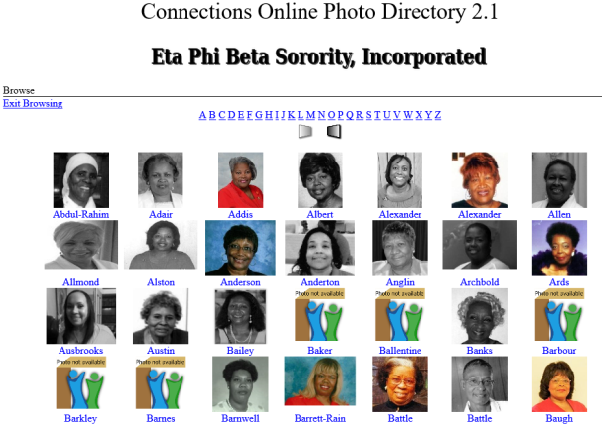

* + 1. The Sorors’ names are listed alphabetically and you can click on any name and their information will appear. If a photo is not available you will see “Photo not available” and a family symbol icon
    2. The **Exit Browsing** button will return you to the home page.
    3. You can scroll through the alphabet using the buttons directly beneath the row of letters
    4. If you click on one of the pictures, a Soror’s information will show as noted below

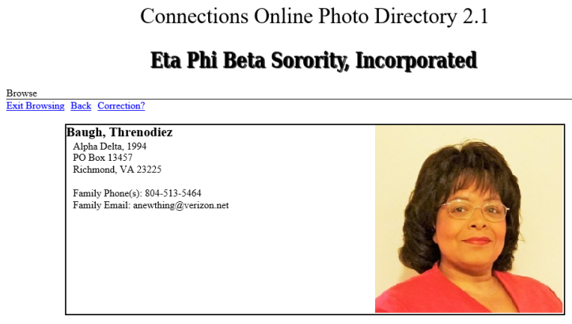

* + - 1. **Exit Browsing –** Will return you to the Home page
      2. **Back –** Will return you to the Browse page
      3. **Correction? -** Clicking this will take you to a page where you can submit corrections if your information is incorrect. See below for additional instructions regarding **Submitting Corrections.**

1. **Photo Directory**
   1. When you click this icon, it will automatically generate a ***pdf*** file named ***Phone.*** This is the **Photo Directory**. ***It can be downloaded, renamed, and saved to your computer***. If we have a picture for you, it will appear in this directory.
   2. Information includes: Name, address, chapter, year of induction, phone number, email address, and photo if one was provided.
   3. NOTE: Most web browsers will prompt you to Open or Save the document.
2. **Text Directory**
   1. By **clicking** the Text Directory icon, a ***pdf*** file named ***Phone*** will automatically generate. This is the **Text Directory**. ***It can be downloaded, renamed, and saved to your computer***.
   2. The Text Directory only displays Name, address, chapter, year of induction, phone number, and email address – No Photos
   3. NOTE: Most web browsers will prompt you to Open or Save the document.
3. **SUBMITTING CORRECTIONS**
   1. If you click on the **Correction?** Icon, the following screen will appear

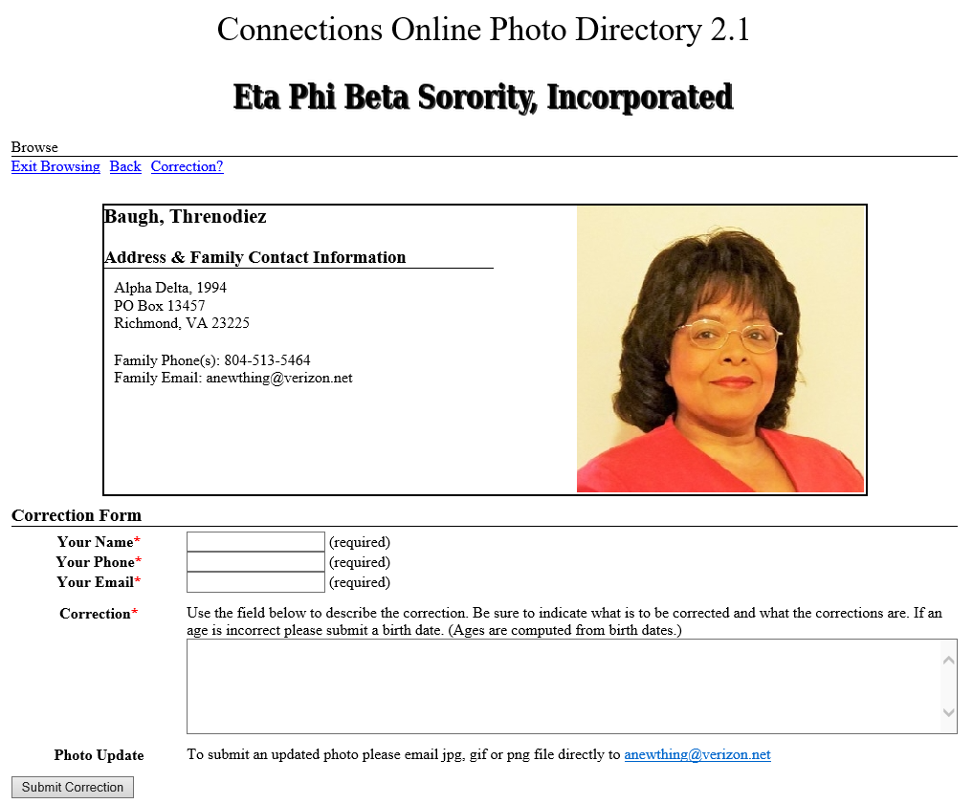

* + 1. You will note that your Name, Phone number, Email address and the Correction are required
    2. Please be specific as you indicate what information needs to be changed/updated.
    3. If you do not have an email address, you can use the ***Membership Status Information Change Form*** found in the Members Only page of the sorority’s website.
    4. If you want to submit a new photo, **see the ETA PHI BETA SORORITY, INCORPORATED PROFESSIONAL HEADSHOT PHOTO GUIDELINES** for the criteria.
    5. Send an email to the address noted with the picture attached to the email. **The subject line should include your** **NAME, CHAPTER and REGION**
    6. Once you have emailed the photo, (if applicable), click the **Submit Correction** button to send the other corrections/updates to the administrator.

**ETA PHI BETA SORORITY, INCORPORATED**

**PROFESSIONAL HEADSHOT PHOTO GUIDELINES**

The following guidelines should be used when preparing to submit a photo for inclusion in the sorority directory. Email the picture to [anewthing@verizon.net](mailto:anewthing@verizon.net). **The subject line should include your** **NAME, CHAPTER and REGION** (example: Sonda Bradfield – Delta Psi – SER).

* **Acceptable Photo Formats and Size**: The picture should be at least 1 megapixel (**1280x960**) head and shoulder shot in a **JPG** or **PNG** format ***with no cropping.***
* **Use Natural or Professional Lighting:** Proper lighting is essential to any good image. Select natural light from windows on multiple ends of the room, or a professional lighting setup.
* **Keep the Backdrop Simple:** Ensure that the background does not distract from the main focal point of the image - you.
* **The Dress:** Generally speaking, solid, neutral colors, work best, as to avoid anything that distracts away from your face. Red attire is acceptable.
* **Hair and Make-Up:** Simple is best.
* **Posture:** Good posture is essential since it exudes confidence and professionalism. Simply sit with your back straight and your shoulders back while remaining relatively relaxed.
* **Smile:** We all know how to smile. However, we want your smile to look natural and effortless. Play with using different smiles (big smiles, medium smiles and small smiles).