

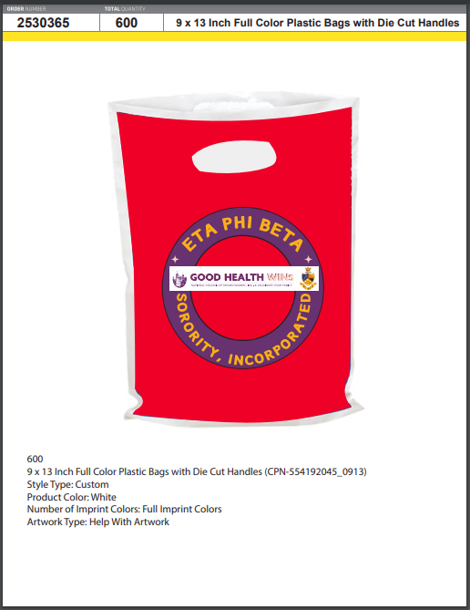

**Instructions**

Contact: 24 HourWristbands.com

1-855-711-4467

1. Use the corresponding Order Number to order bags or fans.
2. Use **your** shipping address and **your** form of payment to complete the order.
3. Allow 2 weeks turn-around time.
4. Submit request for Reimbursement. (Link attached)

https://drive.google.com/file/d/1oIHakNMdJXDyP3HA7_qknIeKo2kv4Uq7/view?usp=sharing

**Order Number for the Bags is:**

**IMA738421742**

**Order Number for the Fan is:**

**IMA7C0C28843**